1) Find the IP address of your computer ( ipconfig, ifconfig )

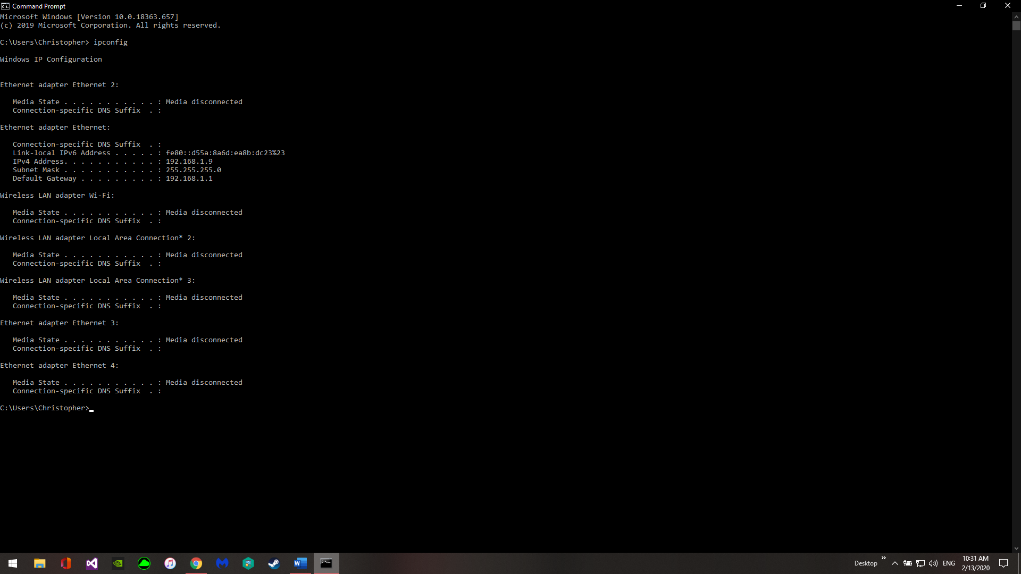

2) Find the IP address of [wasp.cs.kent.edu](http://www.cs.kent.edu/) ( ping, tracerote )

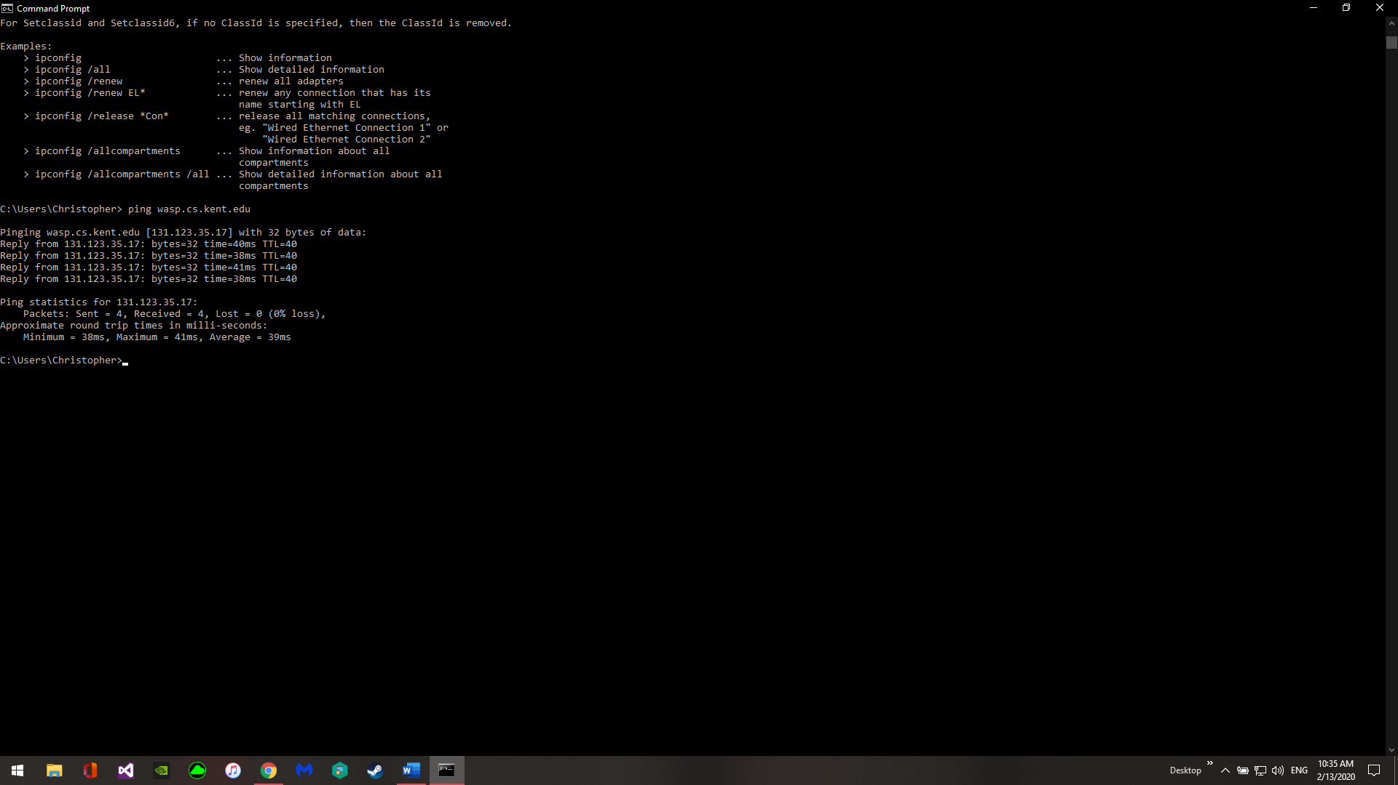

3) Find the GPS of the IP addresses found

* You can use https://www.textmagic.com/free-tools/ip-address-geo-location-tool or other similar sites

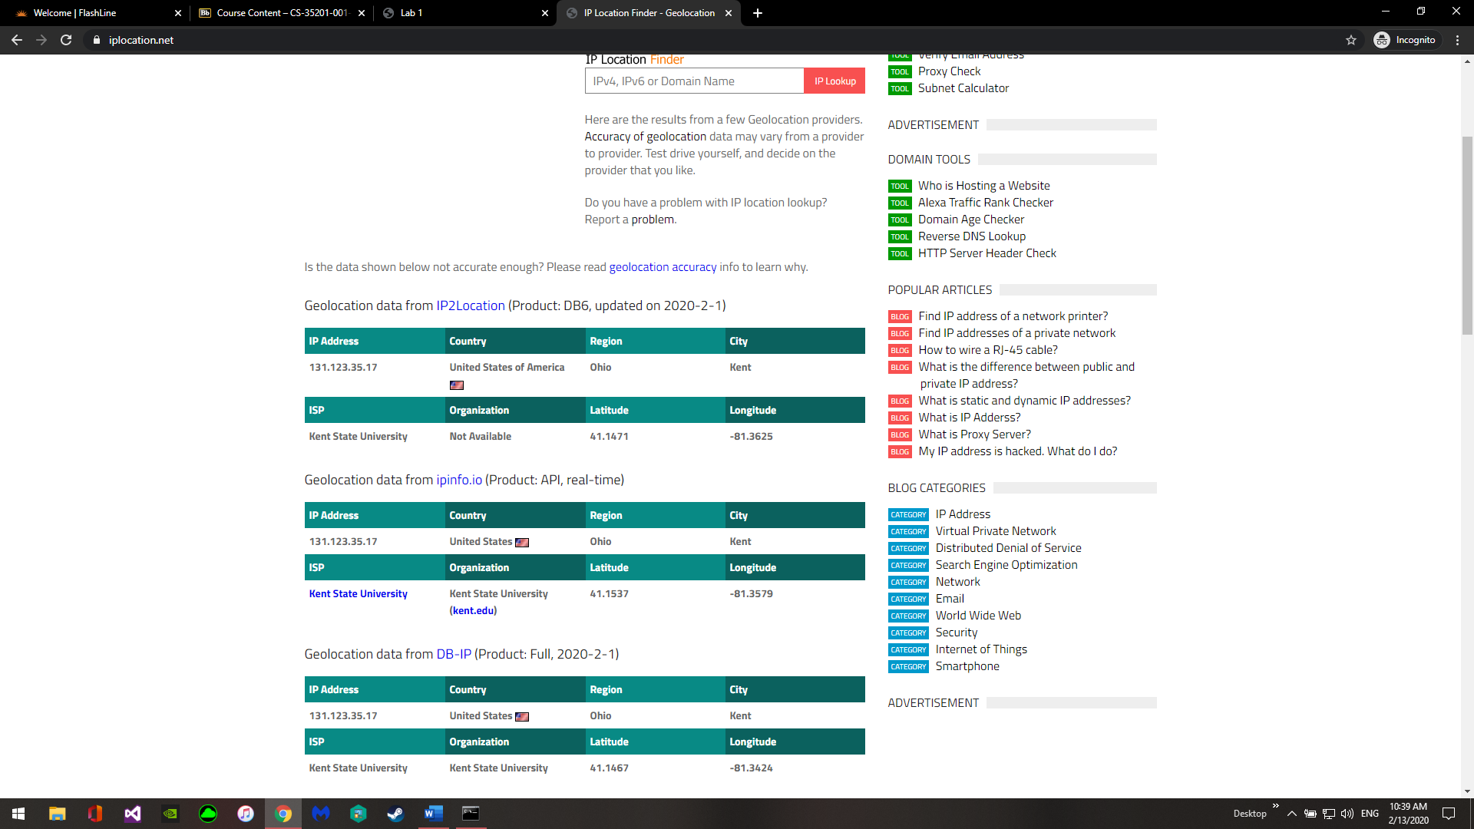

4) Measure the delay (RTT) from your computer to wasp.cs.kent.edu ( ping, tracerote )

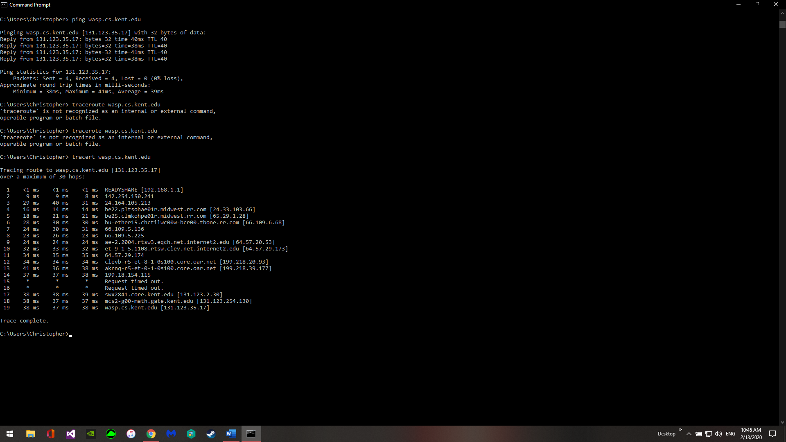

5) Collect 100 samples of round-trip times

1. Plot a histogram (distribution) of your data. You can use online tools such as http://www.shodor.org/interactivate/activities/Histogram/, use a spread sheet or write your own code in Python, Matlab, R, C++. Most software tools come with statitistical packages.

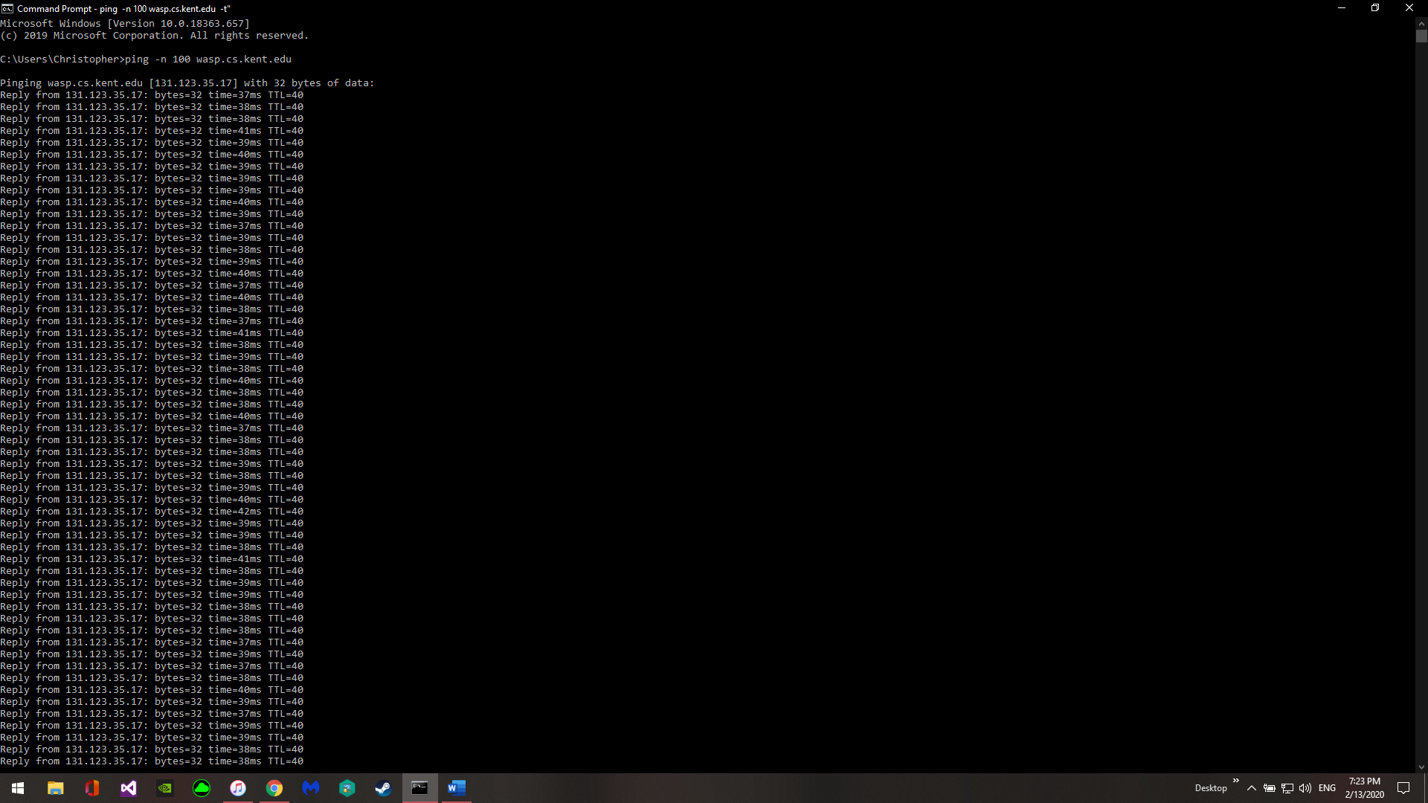

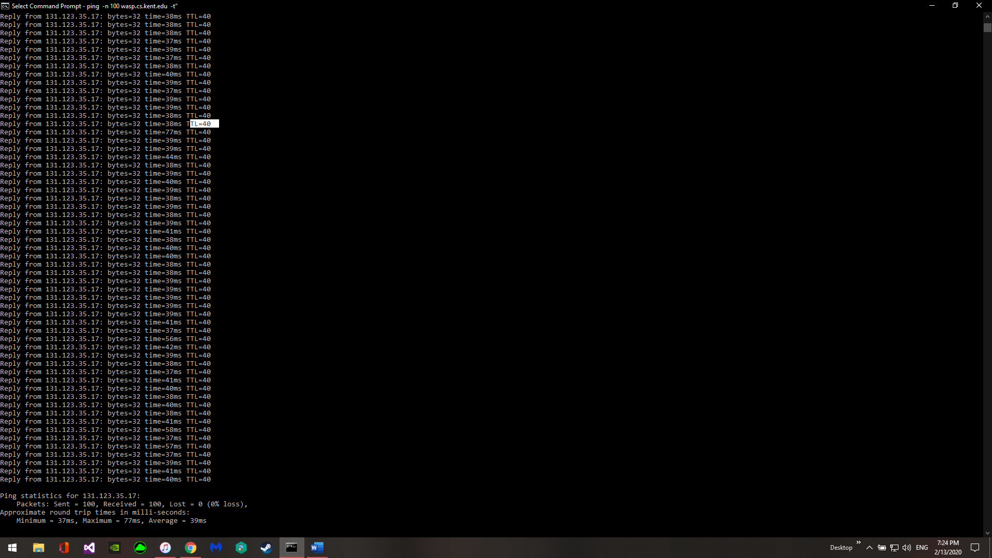

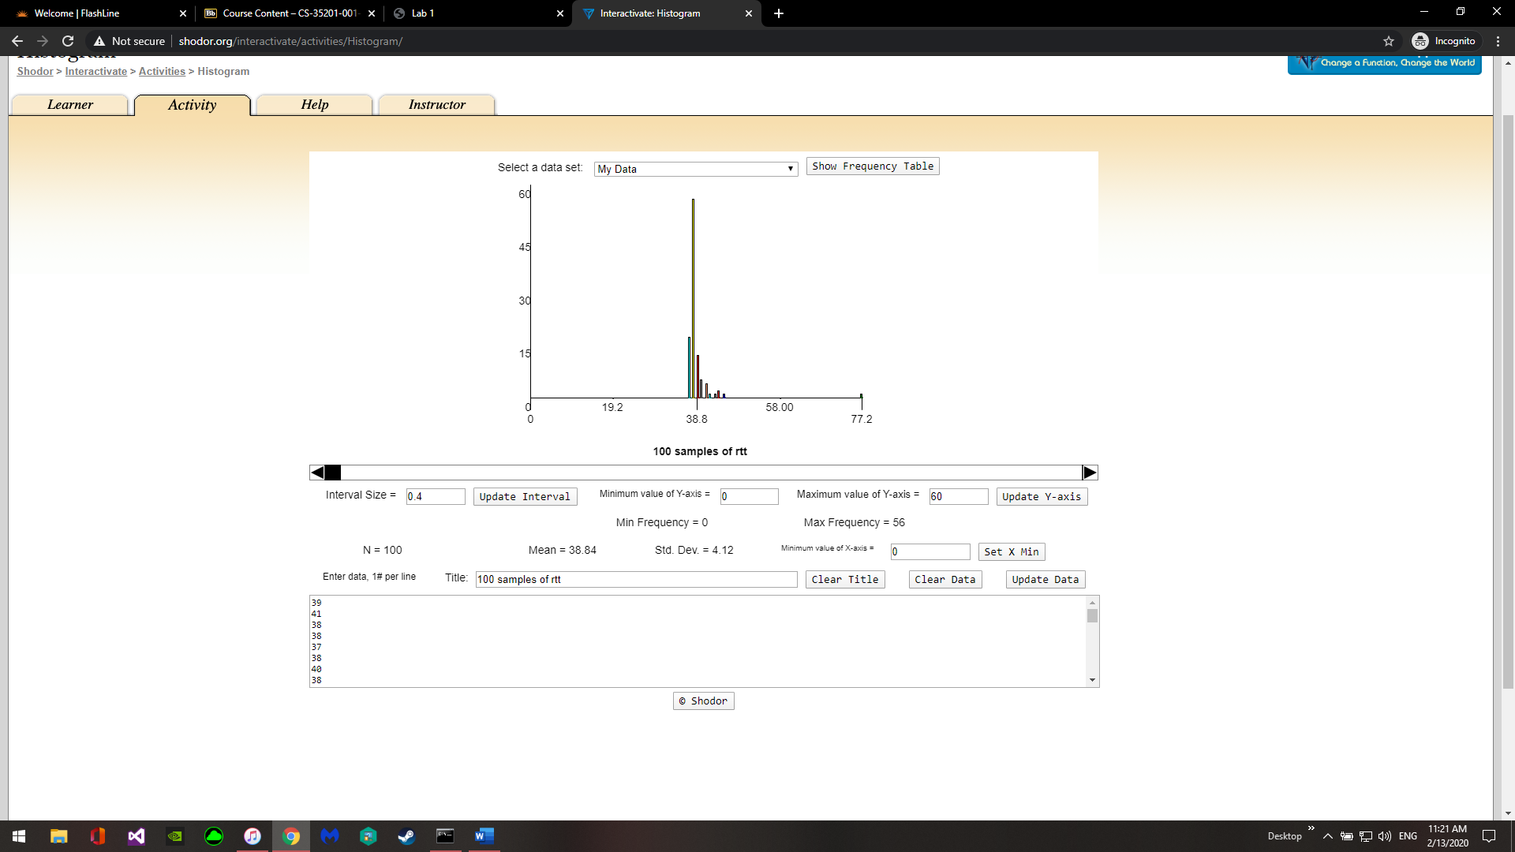

1. What do you observe? Normal distribution or something else?

It’s not a normal distribution as that would have many values to the left and the right of the peak. This distribution has one very large peak and then most of the other entries are to the right of the peak.

1. Calculate the mean and variance of the round-trip times

Mean: 38.84ms

Variance: The variance between the max and min is 77-37=40ms

1. Suggest an appropriate time-out based on the mean and variance

An appropriate time-out would be 60ms. This would allow most of the pings to finish while preventing too long of a wait on the outliers.